**Lobbyist Registry Data Mart**

**Business Need:**

a. What are the count of correspondences (use COMLOG_ID) and cost of communication

per sender per subject per institution per client per year/month?

b. What is the correlation between month, subject and institute

|  |  |  |
| --- | --- | --- |
| **Measure** | **OLTP Fields** | **Data Type** |
| CostOfCommunication | Rejected flag | Int |

Figure 1. Finalized measures for the Lobbyist Registry Data Mart

|  |  |  |  |
| --- | --- | --- | --- |
| **Dimension** | **OLTP Fields** | **Data Type** | **Parent Dimension** |
| DimClient | DimClient | Int | None |
| DimDate | DimDate | Int | None |
| DimSubject | DimSubject | Int | None |
| DimInstitution | DimInstitution | Int | None |
| DimSender | DimSender | Int | None |

Figure 2. Finalized dimensions and hierarchies for the Lobbyist Registry Data Mart

|  |  |
| --- | --- |
| **LobbyistRegistryFact** | |
| **Field Name** | **Data Type** |
| CostOfCommunication | Int |

Figure 3. The Lobbyist Registry Data Mart schema with measures in a fact table

|  |  |
| --- | --- |
| **LobbyistRegistryFact** | |
| **Field Name** | **Data Type** |
| FactID (PK) | Varchar(500) |
| CostOfCommunication | Int |

|  |  |
| --- | --- |
| **DimClient** | |
| **Field Name** | **Data Type** |
| ClientNumber (PK) | Varchar(500) |
| EnglishNameOfClient | Varchar(500) |
| FrenchNameOfClient | Varchar(500) |

|  |  |
| --- | --- |
| **DimDate** | |
| **Field Name** | **Data Type** |
| DateCode (PK) | Varchar(500) |
| RegistrantNumber | Varchar(500) |
| RegistrantLastName | Varchar(500) |
| RegistrantFirstName | Varchar(500) |
| CommunicationDate | Datetime |
| CertifiedDate | Datetime |
| PostedToRegistryDate | Datetime |

|  |  |
| --- | --- |
| **DimSubject** | |
| **Field Name** | **Data Type** |
| SubjectID (PK) | Varchar(500) |
| SubjectOfCommunication | Varchar(500) |

|  |  |
| --- | --- |
| **DimInstitution** | |
| **Field Name** | **Data Type** |
| InstitutionID (PK) | Varchar(500) |
| ManuallyEnteredInstitution | Varchar(500) |
| Institution | Varchar(500) |

|  |  |
| --- | --- |
| **DimSender** | |
| **Field Name** | **Data Type** |
| SenderID (PK) | Varchar(500) |
| SenderLastName | Varchar(500) |
| SenderFirstName | Varchar(500) |
| SenderPositionTitle | Varchar(500) |
| SenderBranch | Varchar(500) |

Figure 4. The Lobbyist Registry Data Mart schema with dimension tables added

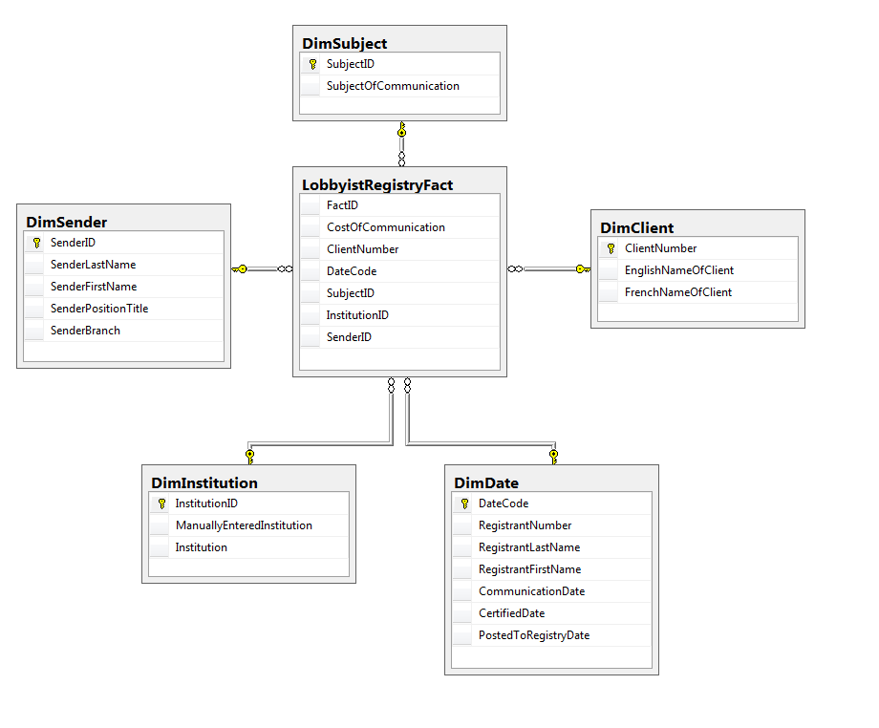

Figure 5. The Lobbyist Registry Data Mart Diagram

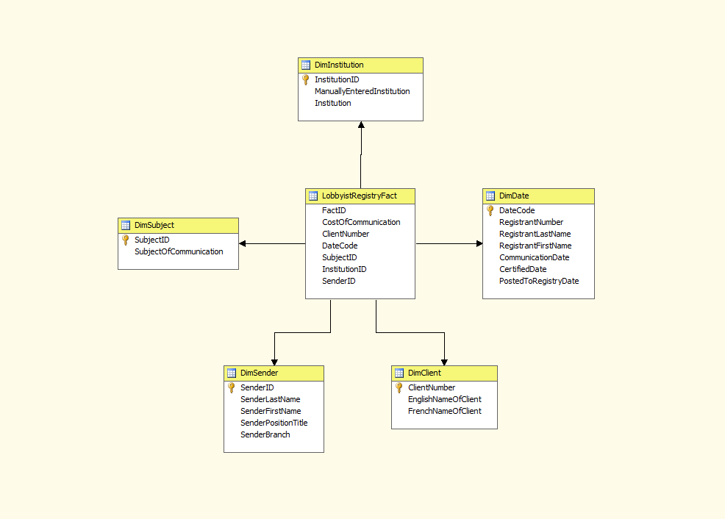

Figure 6. The Lobbyist Registry Data Mart Cube

Master.dtsx

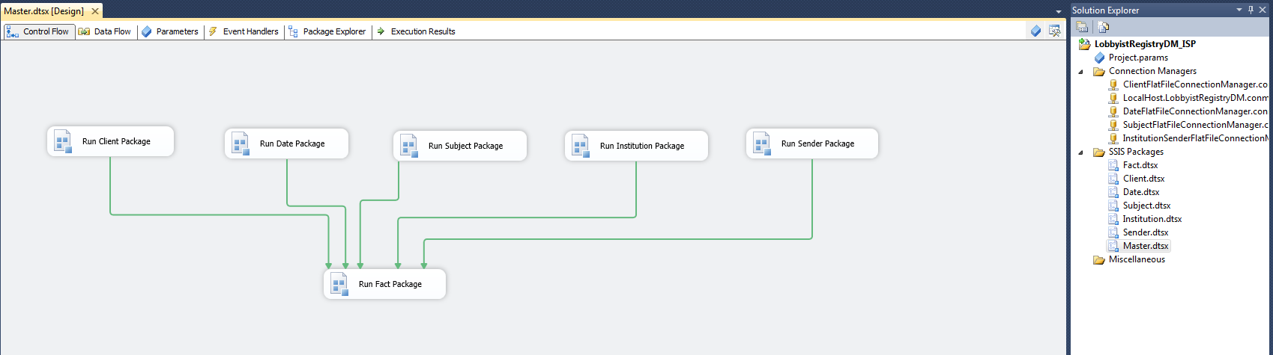

Client.dtsx

A Snapshot of the SSIS package DataFlow

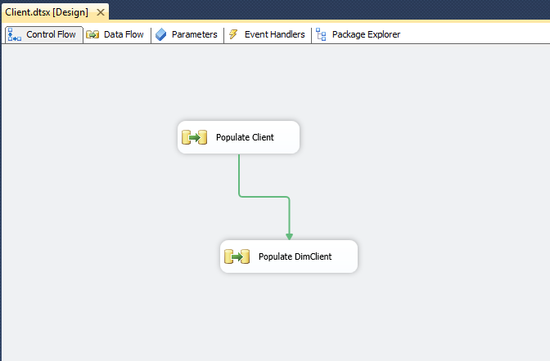

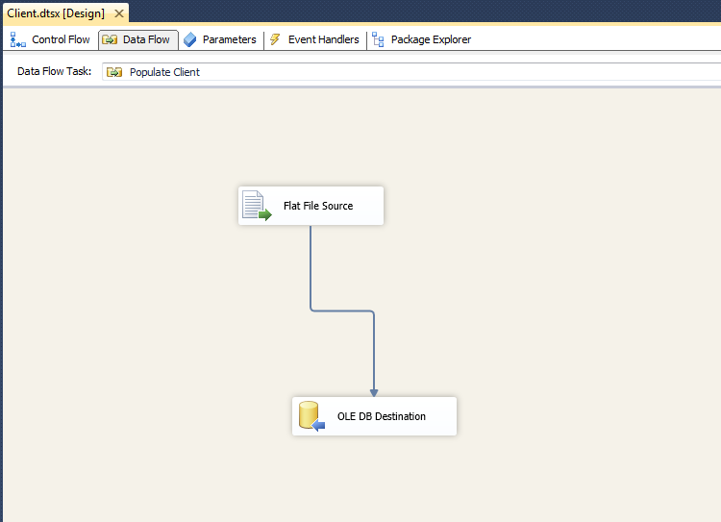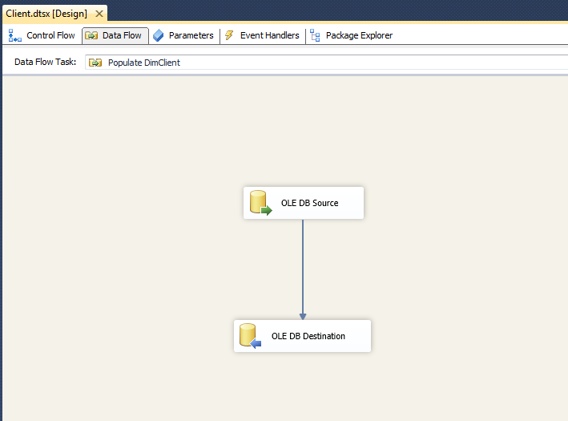

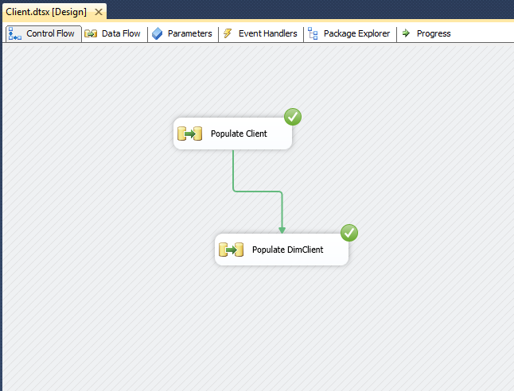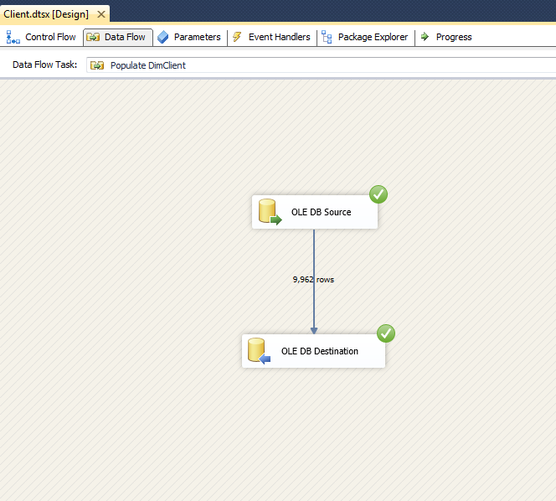

A snapshot of DataFlow MetaData showing the types and sizes of data in SSIS

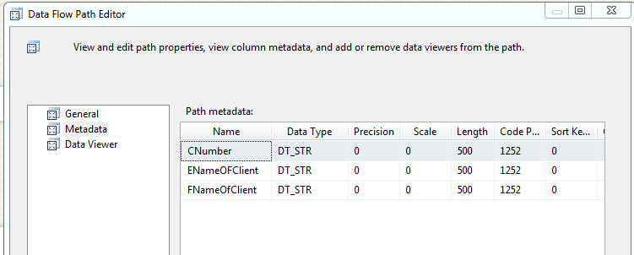

A snapshot of table design view showing the types and sizes of columns in SQL Server

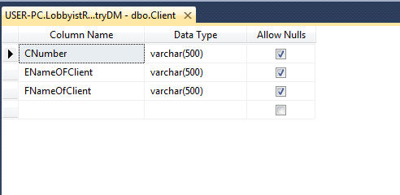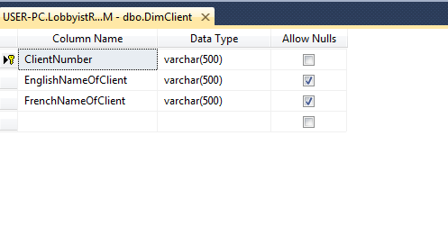

A snapshot of the result of the "Select * from ..." query from your table after successfully running the SSIS package

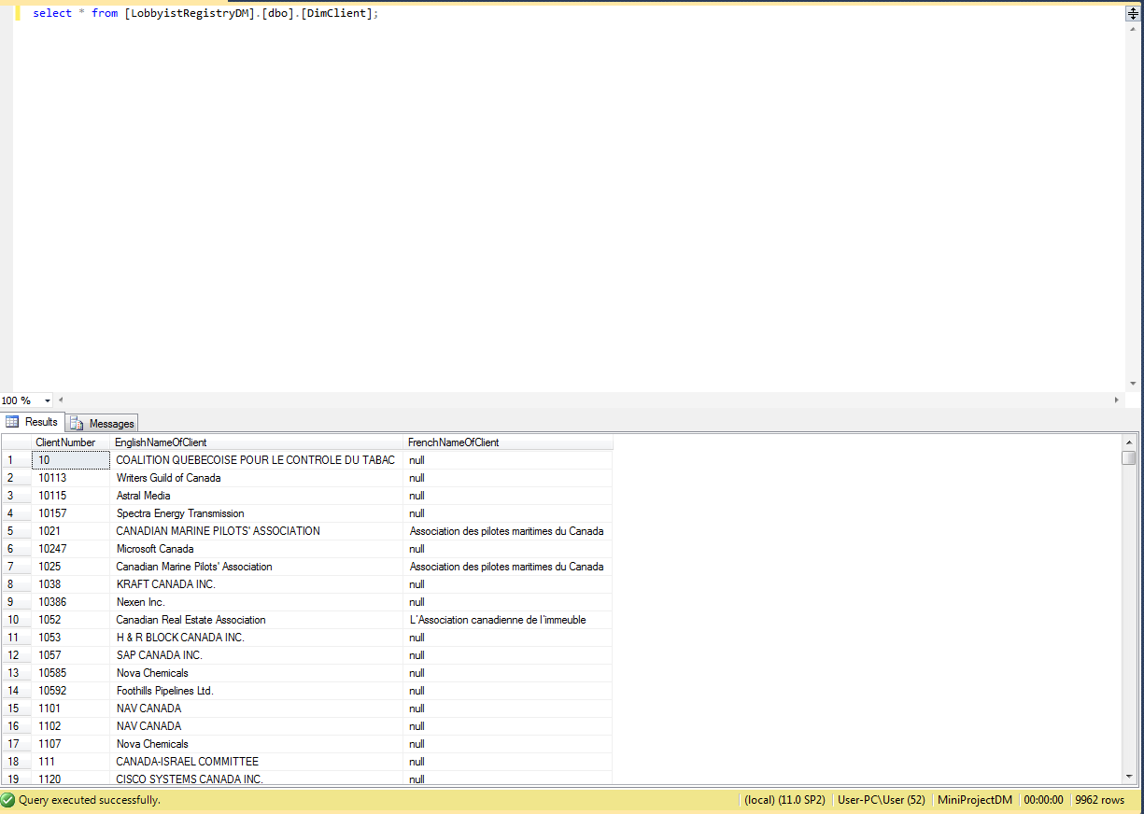

Data.dtsx

A Snapshot of the SSIS package DataFlow

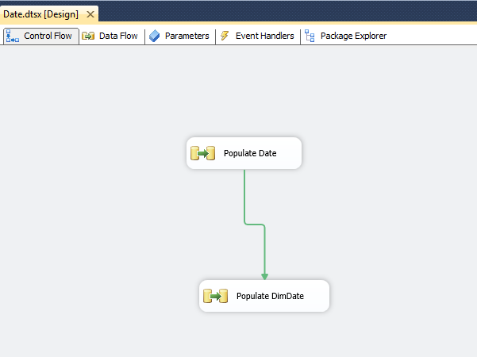

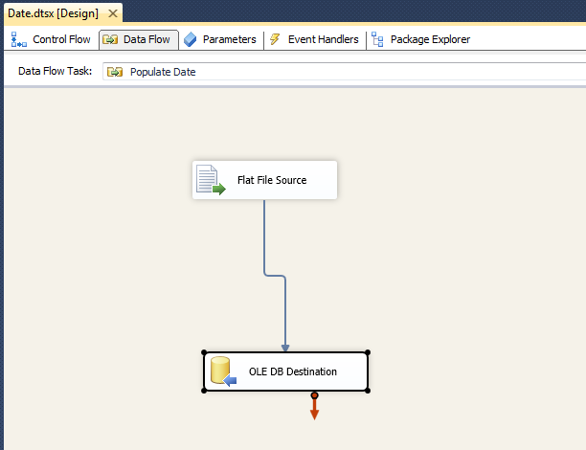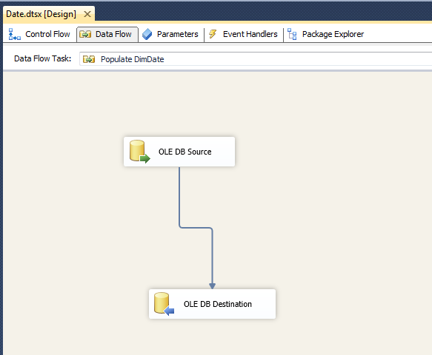

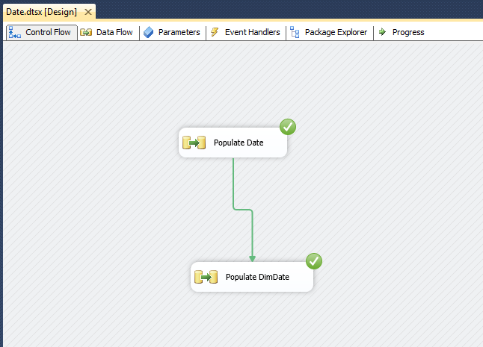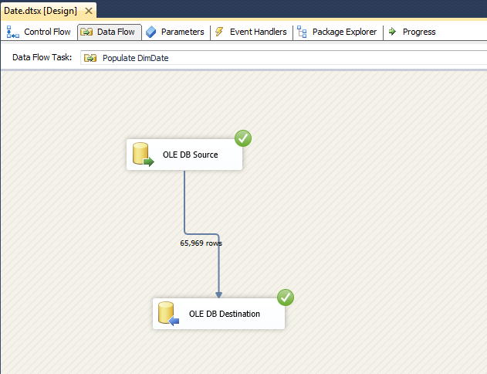

A snapshot of DataFlow MetaData showing the types and sizes of data in SSIS

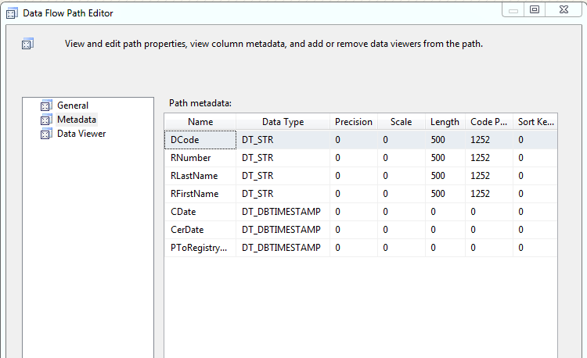

A snapshot of table design view showing the types and sizes of columns in SQL Server

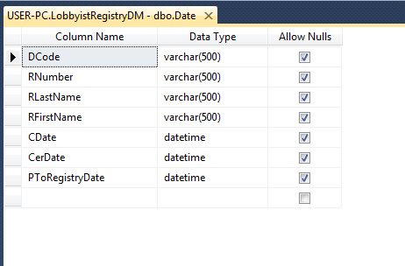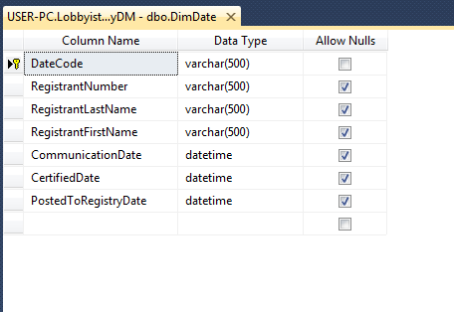

A snapshot of the result of the "Select * from ..." query from your table after successfully running the SSIS package

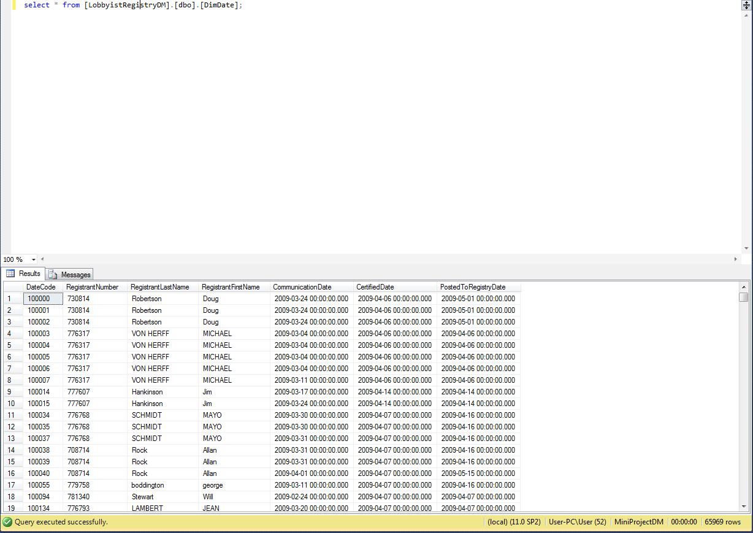

Subject.dtsx

A Snapshot of the SSIS package DataFlow

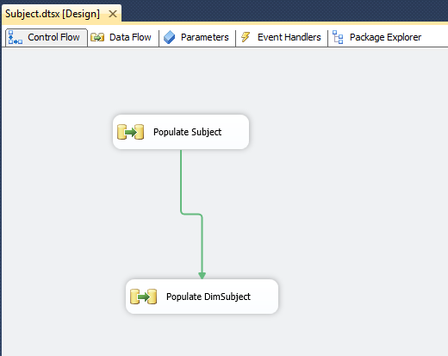

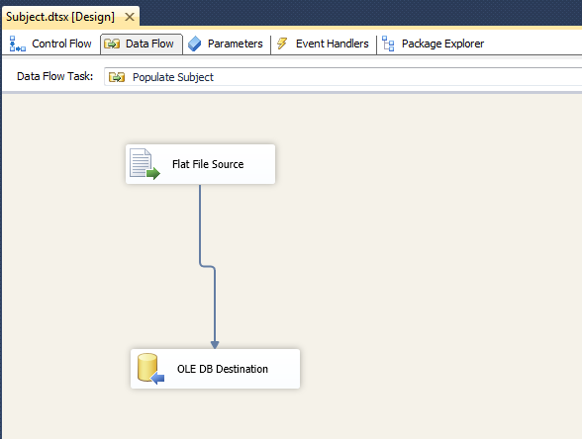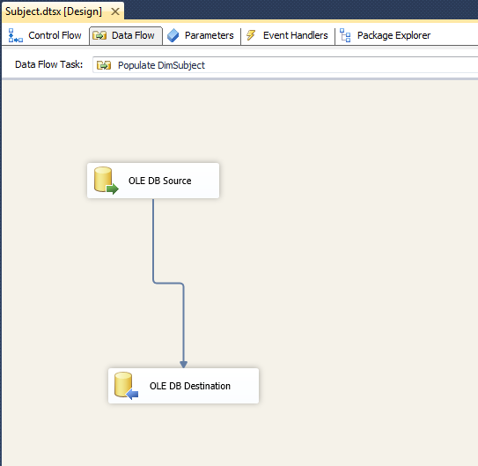

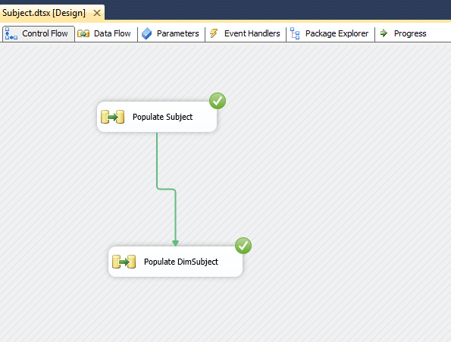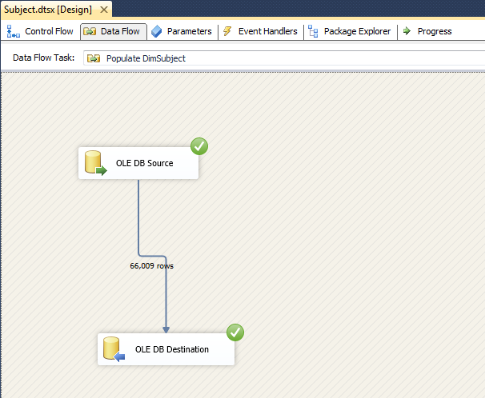

A snapshot of DataFlow MetaData showing the types and sizes of data in SSIS

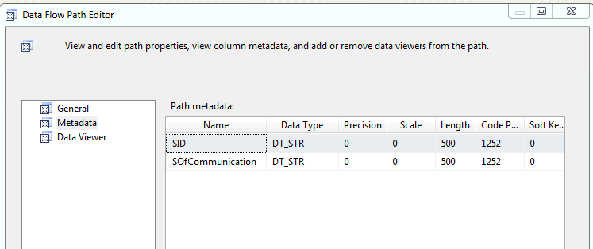

A snapshot of table design view showing the types and sizes of columns in SQL Server

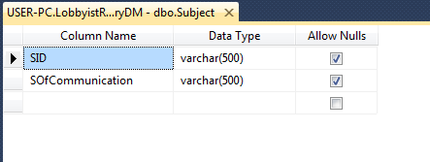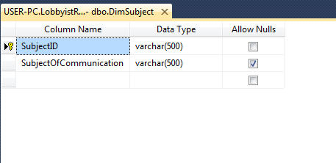

A snapshot of the result of the "Select * from ..." query from your table after successfully running the SSIS package

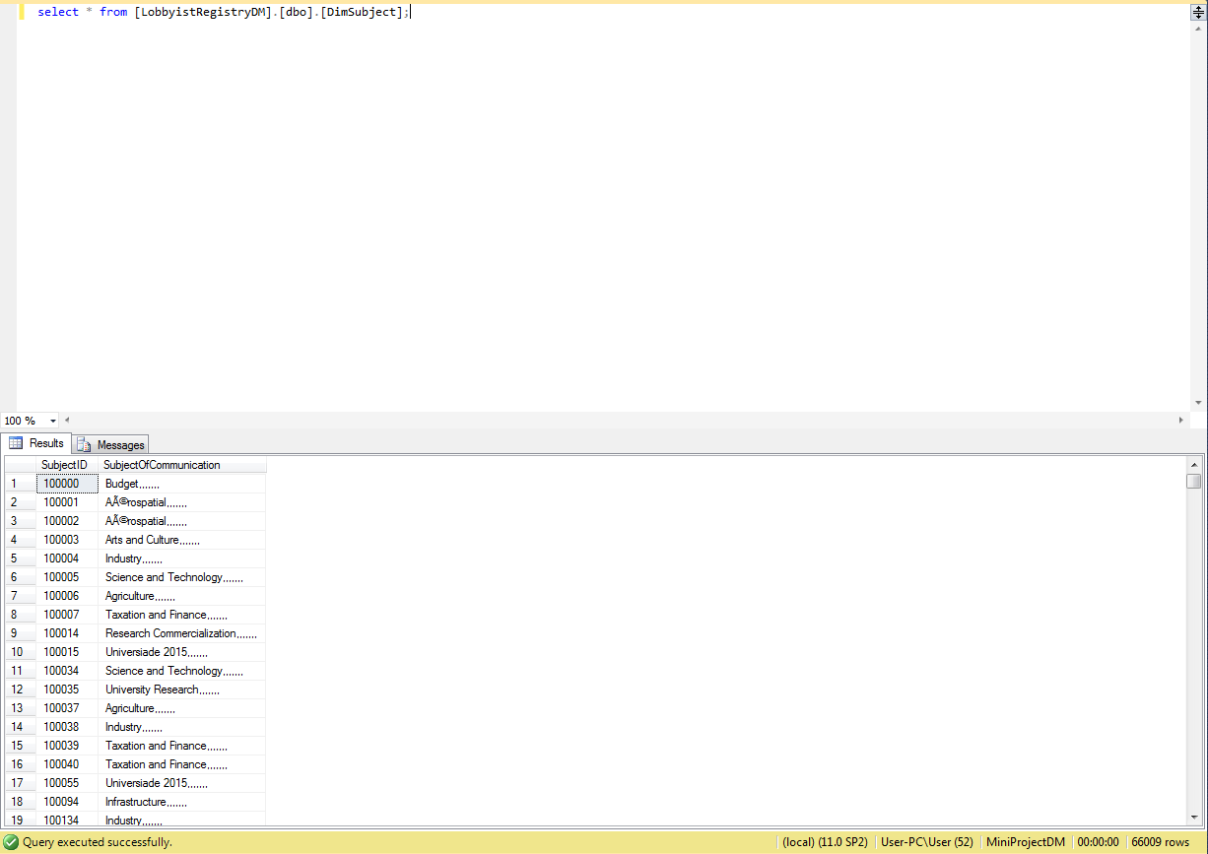

Institution.dtsx

A Snapshot of the SSIS package DataFlow

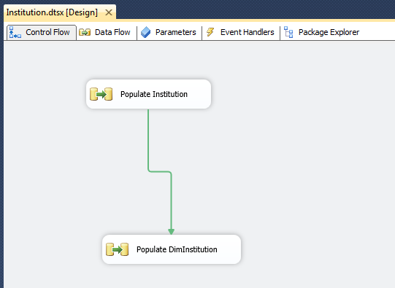

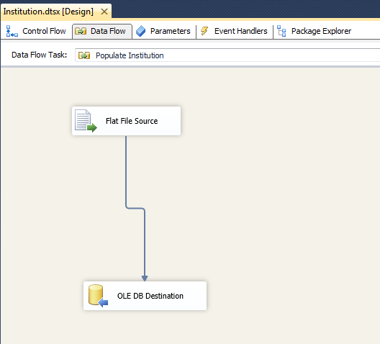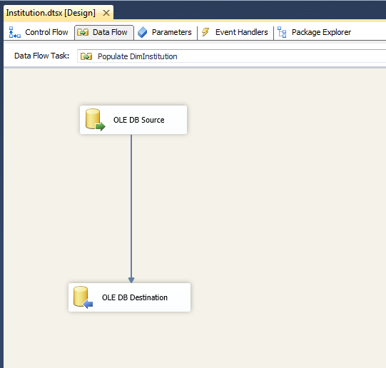

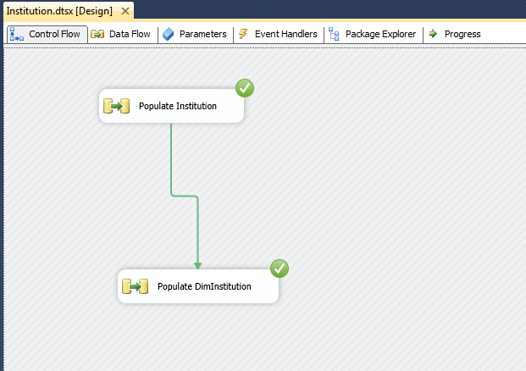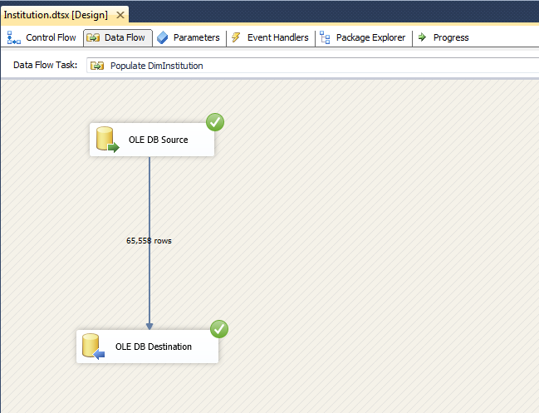

A snapshot of DataFlow MetaData showing the types and sizes of data in SSIS

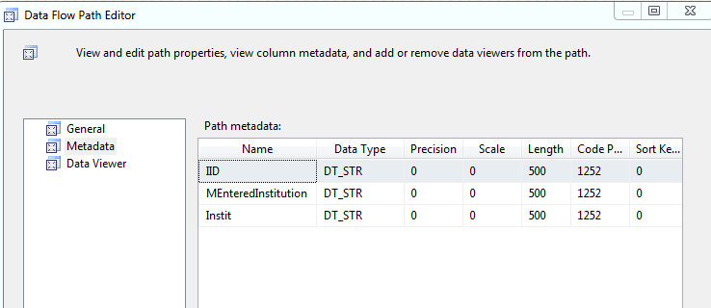

A snapshot of table design view showing the types and sizes of columns in SQL Server

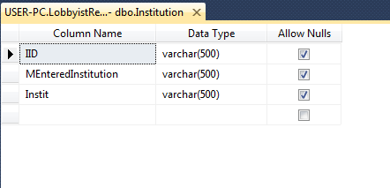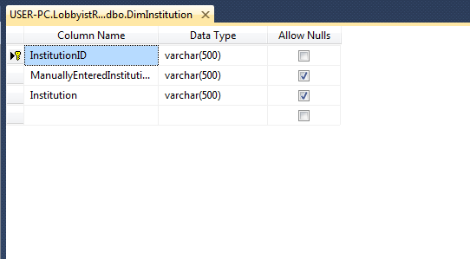

A snapshot of the result of the "Select * from ..." query from your table after successfully running the SSIS package

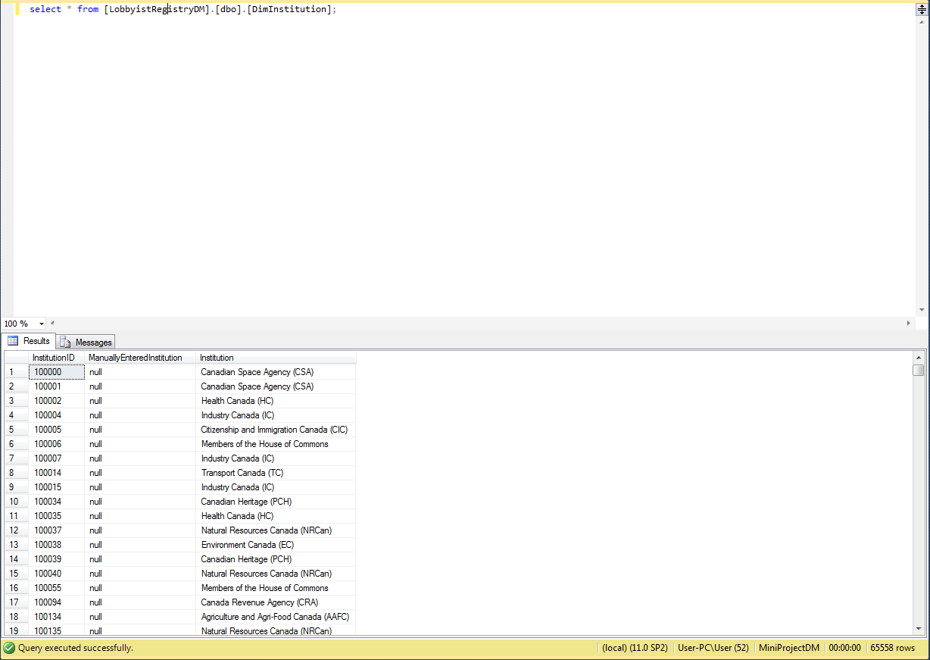

Sender.dtsx

A Snapshot of the SSIS package DataFlow

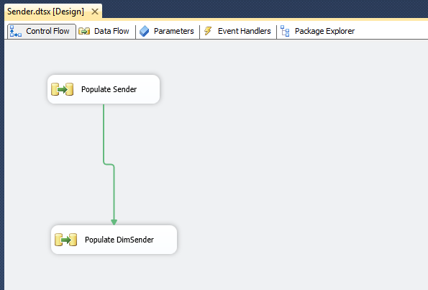

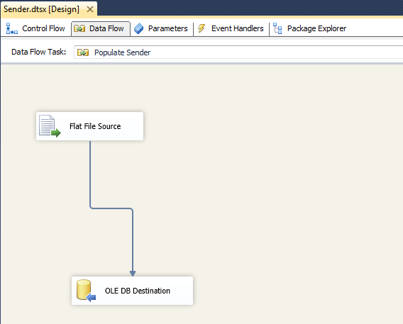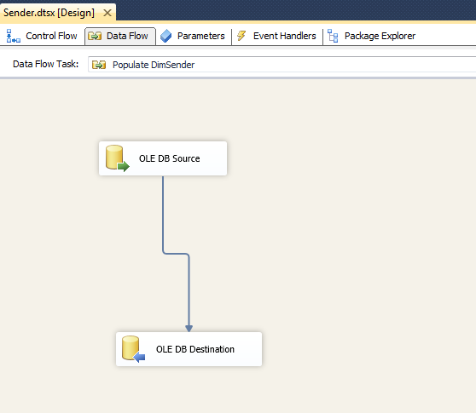

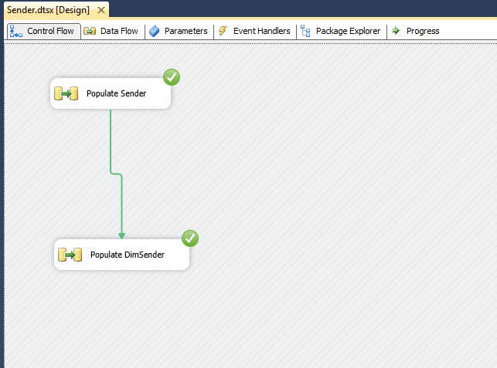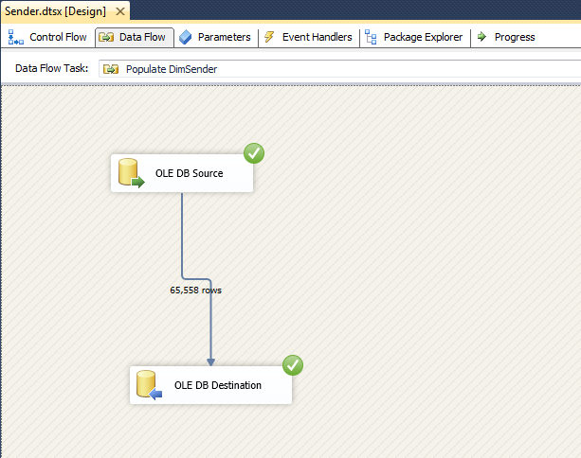

A snapshot of DataFlow MetaData showing the types and sizes of data in SSIS

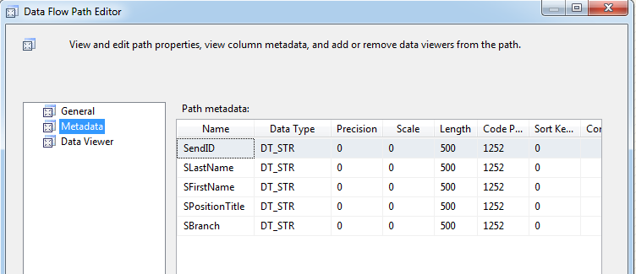

A snapshot of table design view showing the types and sizes of columns in SQL Server

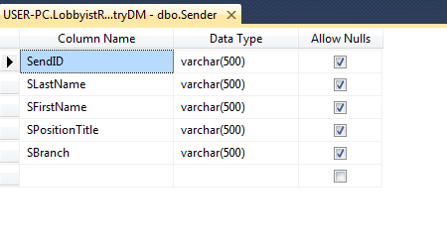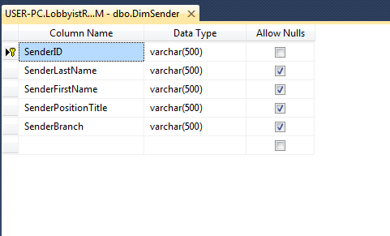

A snapshot of the result of the "Select * from ..." query from your table after successfully running the SSIS package

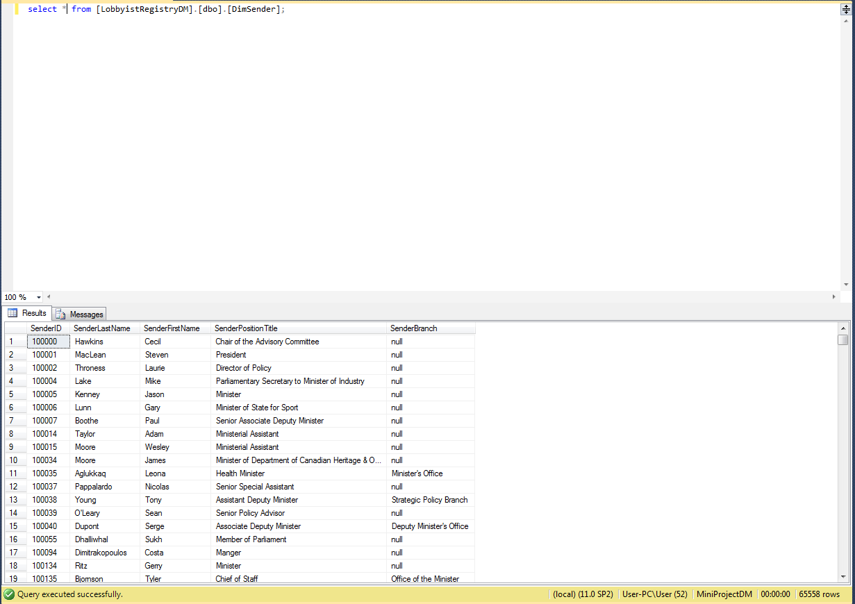

Fact.dtsx

A Snapshot of the SSIS package DataFlow

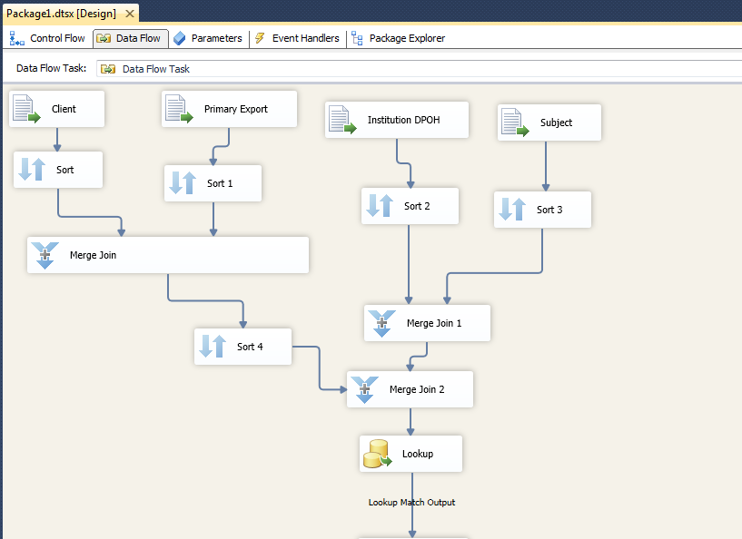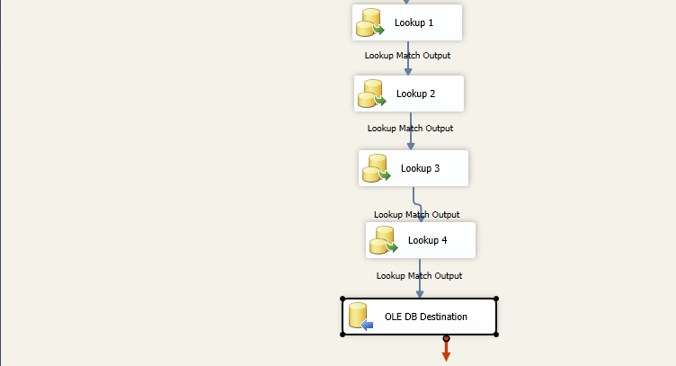

A snapshot of table design view showing the types and sizes of columns in SQL Server

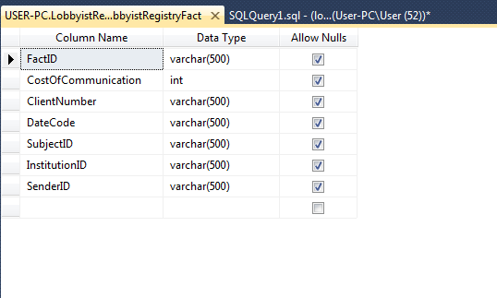

A snapshot of the result of the "Select * from ..." query from your table after successfully running the SSIS package

